H.T No
Regulations:
18

Sreenidhi Institute of Science and Technology
(An Autonomous Institution)
Code No: 7BC02 Date: 07-Feb-2024 (AN)

B.Tech I-Year I- Semester External Examination, Jan/Feb-2024 (Supplementary)
ENGINEERING GRAPHICS AND DESIGN (EEE, ME and ECE)

Time: 3 Hours Max.Marks:70

Note: a) No additional answer sheets will be provided.
b) All sub-parts of a question must be answered at one place only, otherwise it will not be valued.
c) Missing data can be assumed suitably.
Bloom's Cognitive Levels of Learning (BCLL)

Remember | L1 | Apply | L3 | Evaluate | L5
Understand | L2 | Analyze | L4 | Create | L6

Part - A Max.Marks:20

Answer all QUESTIONS.

 |  | BCLL | CO(s) | Marks
1 | Define eccentricity? | L2 | CO1 | [2M]
2 | Draw the projections of a point ‘p’ if it is 20mm above H.P and 15mm infront of V.P. | L2 | CO2 | [2M]
3 | Draw the simple position of a square lamina of side 30mm resting on its corner on H.P. | L2 | CO3 | [2M]
4 | What do you mean by auxiliary view? | L1 | CO4 | [2M]
5 | What is isometric scale? | L2 | CO5 | [2M]
6 | Explain any two editing commands? | L1 | CO6 | [2M]
7 | What are cycloidal curves? | L1 | CO1 | [2M]
8 | Draw the development of square prism of side 25mm and height 50mm. | L1 | CO3 | [2M]
9 | What is the significance of isometric drawing? | L2 | CO5 | [2M]
10 | A line AB 60mm long has its end A 20mm above H.P and V.P. draw the projections if the line is parallel to both H.P and V.P. | L2 | CO2 | [2M]

Part – B Max.Marks:50
ANSWER ANY FIVE QUESTIONS. EACH QUESTION CARRIES 10 MARKS.

 |  |  | BCLL | CO(s) | Marks
11. | a) | Construct a parabola, given distance between directrix and focus as 50mm. | L3 | CO1 | [5M]
 | b) | Construct a plain scale of 1:4 to show centimeters and decimeters, long enough to measure upto 5 decimeter. Show 3.7 decimeter on scale. | L4 | CO1 | [5M]
12. | a) | A line AB 60mm long has its end A 15mm above H.P and 10mm infront of V.P. draw the projections of the line AB if the line is 30⁰ inclined to H.P and 45⁰ inclined to V.P. | L4 | CO2 | [5M]
 | b) | Draw the projections of the following points maintaining distance 25mm between the projectors.  - A point ‘A’ is 20mm above H.P and 15mm infront of V.P  - A point ‘B’ is 15mm above H.P and 10mm behind V.P.  - A point ‘C’ is 25mm below H.P and 20mm behind V.P.  - A point ‘D’ is 30mm below H.P and 25mm infront of V.P. | L4 | CO2 | [5M]
13. | a) | A pentagon of side 25mm is resting on its corner on H.P, such that its surface is 30⁰ inclined to H.P. draw its projections. | L3 | CO3 | [5M]
 | b) | A hexagonal pyramid of base side 25mm and axis 55mm long is resting on one of its triangular faces on H.P. draw its projections. | L3 | CO3 | [5M]
14. | a) | A pentagonal pyramid, base side 30mm, axis 60mm long is resting on its base on H.P with one side perpendicular to V.P. it is cut by a section plane perpendicular to V.P and inclined at 30⁰ to H.P, bisecting the axis. Draw front view and sectional top view. | L3 | CO4 | [5M]
 | b) | A cone of base circle diameter 50mm and height 60mm is resting on its base on H.P, it is cut by a section plane perpendicular to V.P and parallel to H.P, passing through a point on the axis 15mm from the apex. Draw front view and sectional top view. | L3 | CO4 | [5M]
15. | a) | Draw the isometric projection of a hexagon of side 30mm. | L2 | CO5 | [5M]
 | b) | Draw the isometric view of a cylinder of base circle diameter 30mm and height 60mm when it is resting on its base on the ground. | L2 | CO5 | [5M]
16. | a) | Draw front view, top view and side view of the below object using first angle projection. All dimensions are in ‘mm’  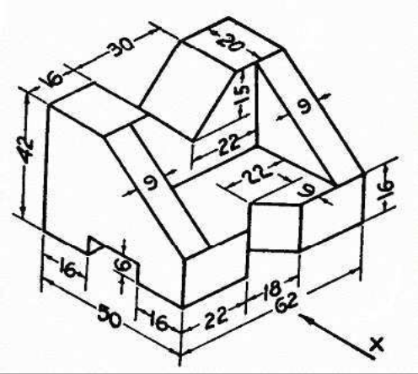 | L4 | CO6 | [5M]
 | b) | What is the function of ‘OSNAP’ command in AutoCAD? Explain with an example. | L1 | CO6 | [5M]
17. | a) | Construct a pentagon using general method, assume side of pentagon as 25mm. | L2 | CO1 | [4M]
 | b) | Draw the projections of a line AB 60mm long has its end A 20mm above H.P and 10mm infront of V.P, the line is perpendicular to H.P and parallel to V.P. | L2 | CO2 | [3M]
 | c) | Draw the projections of a circle of diameter 50mm, resting on V.P, its surface is 40⁰ inclined to V.P. | L3 | CO3 | [3M]
18. | a) | A square pyramid of base side 25mm and axis 50mm long is resting on its base on H.P. it is cut by a section plane perpendicular to H.P and parallel to V.P, passing through 6mm from the center of the axis. Draw front view and sectional top view. | L3 | CO4 | [4M]
 | b) | Draw the isometric view of a circle whose diameter is 50mm | L2 | CO5 | [3M]
 | c) | Explain the command polyline? | L1 | CO6 | [3M]
-- 00 -- 00 –

